Simple Mail Transfer Protocol (SMTP)

- Email is emerging as one of the most valuable services on the internet today.
- Most of the internet systems use SMTP as a method to transfer mail from one user to another.
- SMTP is a push protocol and is used to send the mail whereas POP (post office protocol) or IMAP (internet message access protocol) are used to retrieve those mails at the receiver’s side.
SMTP Fundamentals
SMTP is an application layer protocol.
- The client who wants to send the mail opens a TCP connection to the SMTP server and then sends the mail across the connection.
- The SMTP server is always on listening mode.
- As soon as it listens for a TCP connection from any client, the SMTP process initiates a connection on that port (25).
- After successfully establishing the TCP connection the client process sends the mail instantly.
SMTP Protocol
The SMTP model is of two type :
- End-to- end method
- Store-and- forward method
The end to end model is used to communicate between different organizations whereas the store and forward method are used within an organization.
- A SMTP client who wants to send the mail will contact the destination’s host SMTP directly in order to send the mail to the destination. The SMTP server will keep the mail to itself until it is successfully copied to the receiver’s SMTP.
- The client SMTP is the one which initiates the session let us call it as the client- SMTP and the server SMTP is the one which responds to the session request and let us call it as receiver-SMTP.
- The client- SMTP will start the session and the receiver-SMTP will respond to the request
Model of SMTP system
- In the SMTP model user deals with the user agent (UA) for example Microsoft Outlook, Netscape, Mozilla, etc.
- In order to exchange the mail using TCP, MTA is used.
- The users sending the mail do not have to deal with the MTA it is the responsibility of the system admin to set up the local MTA.
- The MTA maintains a small queue of mails so that it can schedule repeat delivery of mail in case the receiver is not available.
- The MTA delivers the mail to the mailboxes and the information can later be downloaded by the user agents.
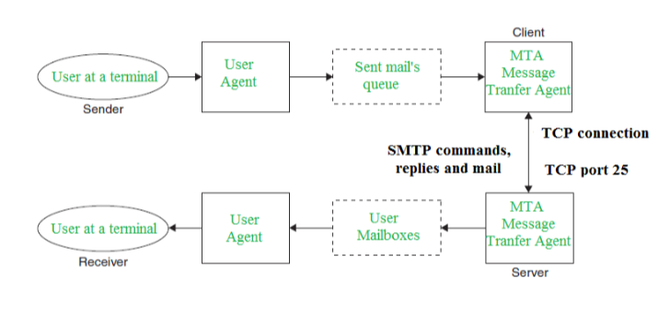
Both the SMTP-client and SMTP-server should have 2 components:
- User agent (UA)
- Local MTA
Communication between sender and the receiver :
The senders, user agent prepare the message and send it to the MTA.
- The MTA functioning is to transfer the mail across the network to the receivers MTA.
- To send mail, a system must have the client MTA, and to receive mail, a system must have a server MTA.
SENDING EMAIL:
Mail is sent by a series of request and response messages between the client and a server. The message which is sent across consists of a header and the body. A null line is used to terminate the mail header. Everything which is after the null line is considered as the body of the message which is a sequence of ASCII characters. The message body contains the actual information read by the receipt.
RECEIVING EMAIL:
The user agent at the server-side checks the mailboxes at a particular time of intervals. If any information is received it informs the user about the mail. When the user tries to read the mail it displays a list of mails with a short description of each mail in the mailbox. By selecting any of the mail user can view its contents on the terminal.
Some SMTP Commands:
- HELO – Identifies the client to the server, fully qualified domain name, only sent once per session
- MAIL – Initiate a message transfer, fully qualified domain of originator
- RCPT – Follows MAIL, identifies an addressee, typically the fully qualified name of the addressee and for multiple addressees use one RCPT for each addressee
- DATA – send data line by line

- Domain Name System (DNS) in Application Layer

- DNS is a host name to IP address translation service.
- DNS is a distributed database implemented in a hierarchy of name servers. It is an application layer protocol for message exchange between clients and servers.
Requirement
Every host is identified by the IP address but remembering numbers is very difficult for the people and also the IP addresses are not static therefore a mapping is required to change the domain name to IP address.
So DNS is used to convert the domain name of the websites to their numerical IP address.
Domain :
There are various kinds of DOMAIN :
- Generic domain : .com(commercial) .edu(educational) .mil(military) .org(non profit organization) .net(similar to commercial) all these are generic domain.
- Country domain .in (india) .us .uk
- Inverse domain if we want to know what is the domain name of the website. Ip to domain name mapping.So DNS can provide both the mapping for example to find the ip addresses of geeksforgeeks.org then we have to type nslookup www.geeksforgeeks.org.
Organization of Domain
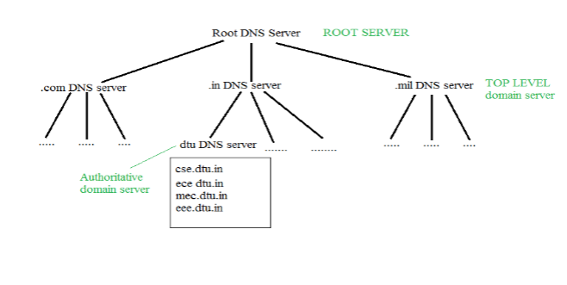
It is Very difficult to find out the ip address associated to a website because there are millions of websites and with all those websites we should be able to generate the ip address immediately,
there should not be a lot of delay for that to happen organization of database is very important.
DNS record– Domain name, ip address what is the validity?? what is the time to live ?? and all the information related to that domain name. These records are stored in tree like structure.

Namespace– Set of possible names, flat or hierarchical . Naming system maintains a collection of bindings of names to values – given a name, a resolution mechanism returns the corresponding value –
Name server– It is an implementation of the resolution mechanism..
- DNS (Domain Name System) = Name service in Internet – Zone is an administrative unit, domain is a subtree.
Name to Address Resolution
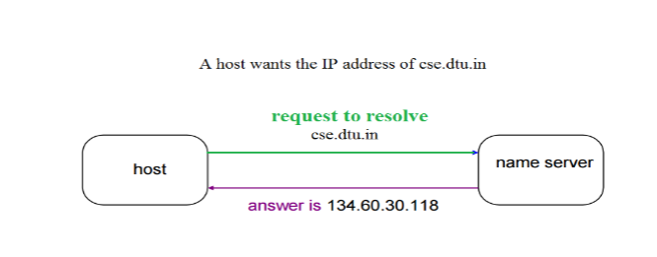
The host request the DNS name server to resolve the domain name. And the name server returns the IP address corresponding to that domain name to the host so that the host can future connect to that IP address.
Hierarchy of Name Servers:-
- Root name servers– It is contacted by name servers that can not resolve the name. It contacts authoritative name server if name mapping is not known. It then gets the mapping and return the IP address to the host.
- Top level server– It is responsible for com, org, edu etc and all top level country domains like uk, fr, ca, in etc. They have info about authoritative domain servers and know names and IP addresses of each authoritative name server for the second level domains.
- Authoritative name servers:-This is organization’s DNS server, providing authoritative hostName to IP mapping for organization servers. It can be maintained by organization or service provider. In order to reach cse.dtu.in we have to ask the root DNS server, then it will point out to the top level domain server and then to authoritative domain name server which actually contains the IP address. So the authoritative domain server will return the associative ip address.

Domain Name Server
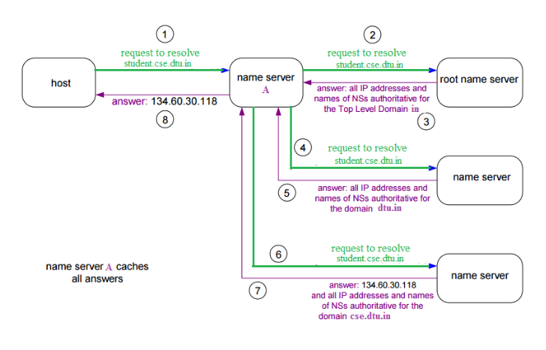
The client machine sends a request to the local name server, which , if root does not find the address in its database, sends a request to the root name server , which in turn, will route the query to an intermediate or authoritative name server. The root name server can also contain some hostName to IP address mappings . The intermediate name server always knows who the authoritative name server is. So finally the IP address is returned to the local name server which in turn returns the IP address to the host.

Address Resolution in DNS (Domain Name Server)
Mapping a domain name to an IP Address is known as Name-Address Resolution.
The Domain Name Server (DNS) Resolver performs this operation by consulting name servers.
In order to find a particular DNS the requesting host place it’s query to the Local DNS Server with a mapping request. If it has the information, the resolver is satisfied else the resolver is referred to other servers or other servers are asked to provide the information. After the resolver, gets the response, it checks whether the response is correct or not. If the response is correct, the response is passed to the process that requested it, else the name query fails.
A resolution can be of two types – iterative and recursive.
- Recursive Resolution –
Here, client requires the Local Server to give either the requested mapping or an error message. A DNS Query is generated by the application program to the resolver to fetch the destination IP Address. The Query is then forward to the local DNS Server. If it knows the IP Address, it sends a response to the resolver. Assuming, it does not know the IP Address, it sends the query to the root name server.
The root name server contains information of about at least one server of Top Level Domain. The query is then sent to the respective Top-Level Domain server. If it contains the mapping, the response is sent back to the root server and then to host’s local server. If it doesn’t contain the mapping, it should contain the IP Address of destination’s local DNS Server. The local DNS server knows the destination host’s IP Address. The information is then sent back to the top-level domain server, then to the root server and then to the host’s Local DNS Server and finally to the host.

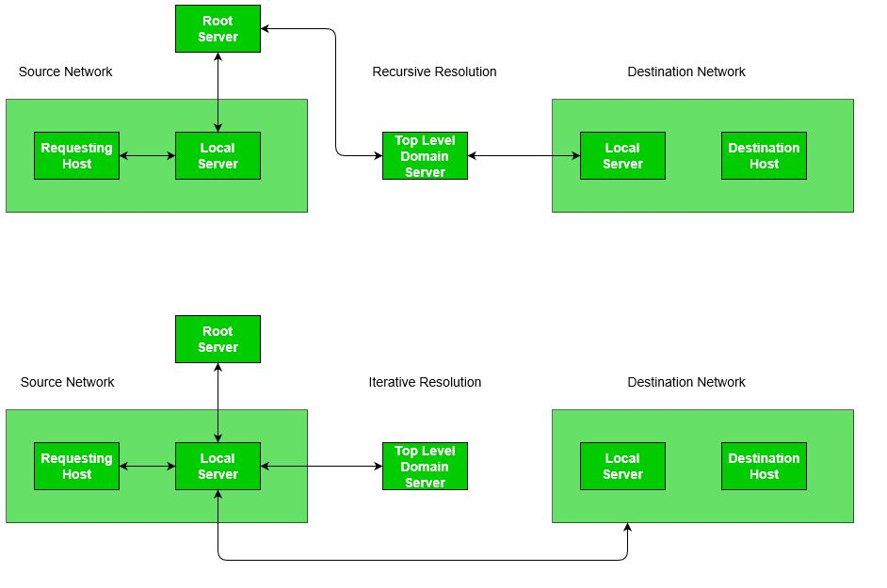
- Iterative Resolution –
The main difference between iterative and recursive resolution is that, here each server that does not know the mapping sends the IP Address of the next server to the one requested it. Here, client allows the server to return the best answer it can give as a match or as a referral. A DNS Query is generated by the application program to the resolver to fetch the destination IP Address. The Query is then forward to the local DNS Server. Assuming, it does not know the IP Address, it sends the query to the root name server.
The root name server returns the IP Address of the Top-Level Domain Server to the Local Server. The Top-Level Domain server is contacted by Local Server and it returns either the IP of the destination host or its local DNS Server. If it returns the server’s address, then by contacting the destination’s Local DNS Server, we get the IP Address of the destination host. The response/mapping is then passed from host’s local DNS server to the resolver and then finally to the host.
Caching Mechanism –
In both iterative and recursive resolution, after a server asks a mapping request from another server, it receives the response and it stores this information in the Cache memory before sending it to the client. This is done to lower the search time it takes for a server to check the IP Address in its Database. So, from the next time, if a request comes to the server, it first checks its cache memory and tries to resolve the request. The response is marked as Unauthoritative to inform the client that the response is from Cache. The only way caching can be problematic is when server caches the mapping for a long time and the mapping gets outdated. However, there are techniques to resolve this like using TTL.

Q.Why does DNS use UDP and not TCP?

DNS is an application layer protocol. All application layer protocols use one of the two transport layer protocols, UDP and TCP. TCP is reliable and UDP is not reliable. DNS is supposed to be reliable, but it uses UDP, why?

- There are following interesting facts about TCP and UDP on the transport layer that justify the above.
- UDP is much faster. TCP is slow as it requires 3-way handshake. The load on DNS servers is also an important factor. DNS servers (since they use UDP) don’t have to keep connections.
- DNS requests are generally very small and fit well within UDP segments.
- UDP is not reliable, but reliability can added on application layer. An application can use UDP and can be reliable by using a timeout and resend at the application layer.

Actually, DNS primarily uses the User Datagram Protocol (UDP) on port number 53 to serve requests. DNS queries consist of a single UDP request from the client followed by a single UDP reply from the server. When the length of the answer exceeds 512 bytes and both client and server support EDNS, larger UDP packets are used. Otherwise, the query is sent again using the Transmission Control Protocol (TCP). TCP is also used for tasks such as zone transfers. Some resolver implementations use TCP for all queries.

DNS Spoofing or DNS Cache poisoning
- A Domain Name System (DNS) converts a human-readable name (such as www.geeksforgeeks.org) to Numeric IP-address.
- The DNS system response one or more IP-address by which your computer connects to a website (such as geeksforgeeks.org) by using one of the IP-address.
- There is not only one DNS server. There are series of DNS server used to resolve the domain name.
- DNS uses cache to work efficiently so that it can quickly refer to DNS lookups it’s already performed rather than performing a DNS lookup over and over again.
Although DNS caching increase the speed for domain name resolution process But the major change in the domain then it takes a day to reflect worldwide.
DNS Spoofing means getting a wrong entry or IP-address of the requested site from DNS server. Attackers find out the flaws in DNS system and take control and will redirect to a malicious website.
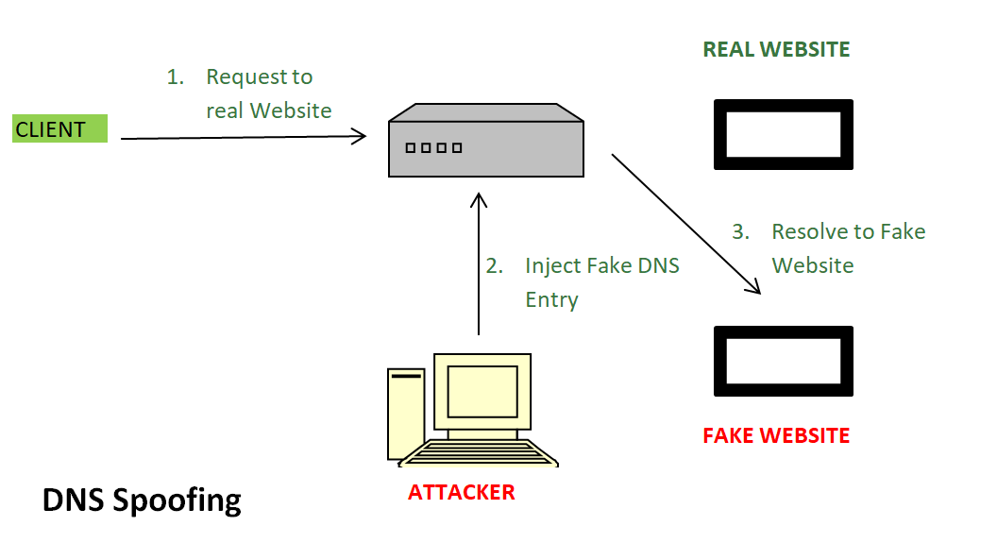
In above image –
- Request to Real Website: User hit a request for paticular website it goes to DNS server to resolve the ip-address of that website.
- Inject Fake DNS entry: Hackers already take control over the DNS server by detecting the flaws and now they add false entry in DNS server.
- Resolve to Fake Website: Since fake entry in DNS server redirect user to wrong website.
To Prevent From DNS Spoofing –
DNS Security Extensions (DNSSEC) is used to add an additional layer of security in DNS resolution process to prevent security threats such as DNS Spoofing or DNS cache poisoning.
DNSSEC protects against such attacks by digitally ‘signing’ data so you can be assured it is valid.

